NSD PROFESSIONAL DEVELOPMENT SYSTEM

INSTRUCTOR GUIDE
HOW TO ACCESS THE PD SYSTEM 2
HOW TO NAVIGATE THE SYSTEM-TABS 2
HOME TAB 2
BADGES TAB 2
COURSES TAB 2
TRANSCRIPT TAB 2
RESOURCES TAB 2
COURSES I AM TEACHING 2
ACCESS THE COURSE ROSTER 3
MANUALLY ADD LEARNERS TO THE ROSTER OR WAITLIST 3
ADD LEARNER 3
ADD LEARNER ADVANCED 5
TAKE ATTENDANCE 6
SIGN IN SHEETS 6
MANAGE ATTENDANCE ONLINE 6
MANAGE ATTENDANCE ON MOBILE APP 8
SUBMIT ATTENDANCE FOR CREDIT APPROVAL 9
MANAGE THE WAITLIST 10
REMOVE PARTICIPANTS 10
EMAIL/MESSAGE PARTICIPANTS 10
ADDITIONAL HELP INFORMATION 11

HOW TO ACCESS THE PD SYSTEM
Type pd.nsd.org into any browser and hit enter.
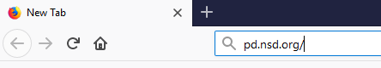
Enter your district username (e.g. jsmith@nsd.org) and click Next.
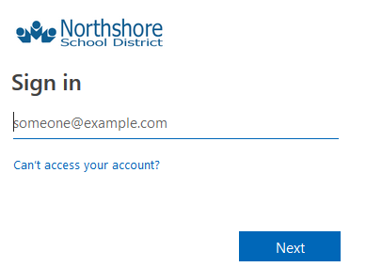
Enter your district password and click Sign in.

HOW TO NAVIGATE THE SYSTEM-TABS

HOME TAB
The Home tab includes a welcome message, information on downloading and using the mobile app, and trainings that have either been marked as recommended or required for you.

BADGES TAB
Northshore is not currently using this function. If badges are created in the future, you will receive information about this tab at that time.

COURSES TAB
The Courses tab allows you to search for courses, find courses using tags, see/manage the courses you are registered for, and complete course surveys.

TRANSCRIPT TAB
The Transcript Tab is where you will find a list of all clock hours you have earned and a printable clock hour transcript.

RESOURCES TAB
The Resources tab provides helpful resources such as documentation and videos, information on clock hour eligibility, sample agendas, and more!

COURSES I AM TEACHING
The Courses I am Teaching tab is where you will see who has enrolled in your section and manage your roster.

ACCESS THE COURSE ROSTER
- Click on the Courses I Am Teaching tab.
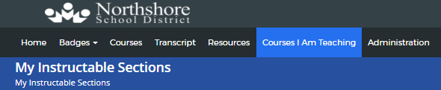
- Next to the desired section, click View Roster. It may be listed under Current Sections, Future Sections, or Past Sections depending on the date.
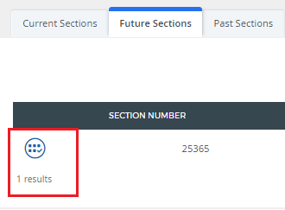

MANUALLY ADD LEARNERS TO THE ROSTER OR WAITLIST
In the section roster, there are two ways for the instructor to register learners for a section: Add Learner or Add Learner Advanced.
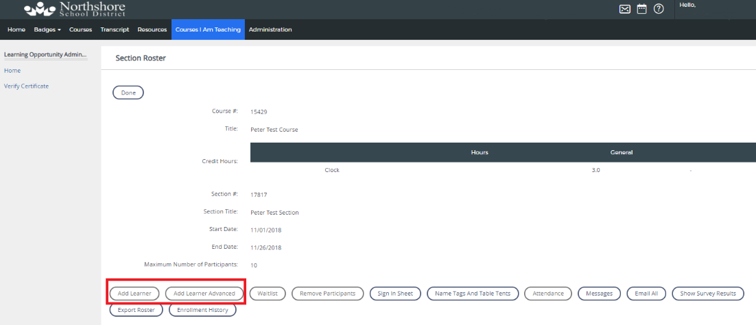

ADD LEARNER
- Click on Add Learner on the Section Roster screen.
- Entered search criteria and click Search.
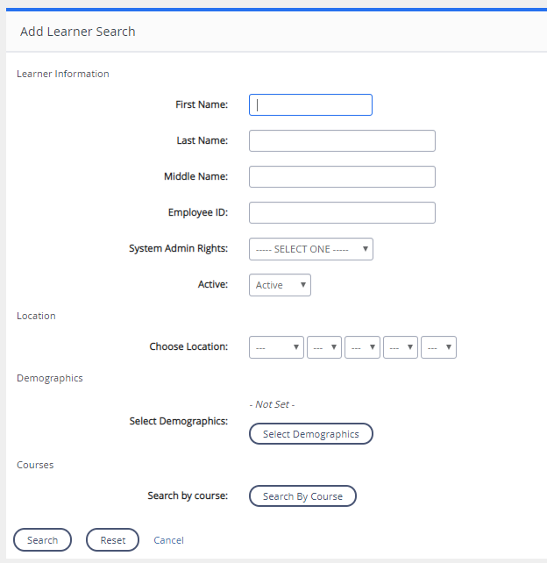
- Check the box next to the learner(s) you would like to add. You can click on users on multiple pages.
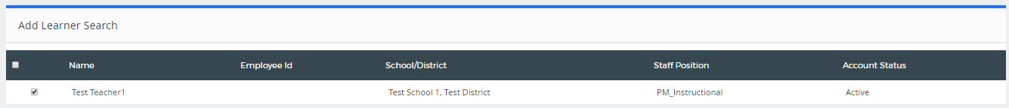
- Check the box of the type of credit that should be awarded for the section. If the course is clock hour eligible, click both the type of clock hours and also participation only (no clock).
- Click Add User(s) to add the users to the roster.
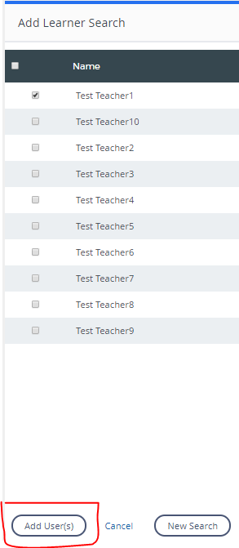

ADD LEARNER ADVANCED
- Click on Add Learner Advanced on the Section Roster screen.
- Click the button next to the type of identifier you would like to use.
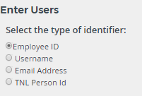
- Enter or copy and paste the identifier you are using in the Input the identifiers box.
- Click the button next to the type of separator you are using to distinguish between the identifiers listed (e.g. email addresses separated by listing each one on a separate line).
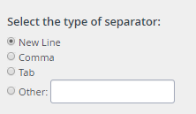
- Click the button next to either the roster or the waitlist if enabled.
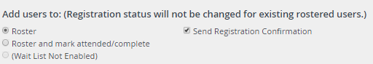
- Click the boxes next the credit type for this section. If the course is clock hour eligible, click both the type of clock hours and also participation only (no clock).
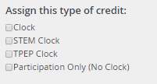
- Click Preview to generate the list of users in the system based on the identifiers added.
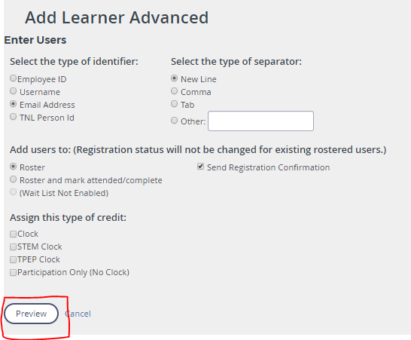
- Review the names listed and then select Add # Users to add them to the roster or waitlist.

TAKE ATTENDANCE
It is the responsibility of the Instructor to take attendance for all sections they are teaching. Once attendance has been taken, Human Resources will award credit for the section (See Submit for Credit Approval). There are multiple options for instructors to take attendance.

SIGN IN SHEETS
- To print a sign in sheet to use to take attendance, click Sign In Sheet on the Section Roster screen.
- Click print on the sign in sheet that is created and follow instructions to print.
- When you are done, close the browser and return to the Section Roster screen.
- Use the sign in sheet to manage attendance using one of the options below.
Note: sign in sheets are no longer required to be sent to Human Resources. We recommend you keep them for your records in the event a participant contacts you in the future about their attendance status.

MANAGE ATTENDANCE ONLINE
- Click Attendance on the Section Roster screen.
- You have multiple options to mark attendance:
  - Click the dropdown under each date for each participant and select their appropriate attendance status.
  - Click the pencil icon next to the user to bulk update the attendance for all dates for that participant and select their appropriate attendance status for all days. You can edit any individual days by clicking the dropdown under the date for that participant.
  - Click the pencil icon in the date column to bulk update the attendance for all participants on that date. You can edit any individual participants by clicking the dropdown under that date for the participant.
- Once you are done taking attendance, click Back on the top left to return to the previous page.

MANAGE ATTENDANCE ON MOBILE APP
Performance Matters offers a mobile app for both instructors and participants to utilize if they are interested. This is an optional feature and you are not required to use it for attendance. The app allows you to view the courses you are listed as the instructor and that you are attending as a participant. It can also be used to take attendance for the course. Instructions for downloading the app to your mobile device are located on the Home Tab.
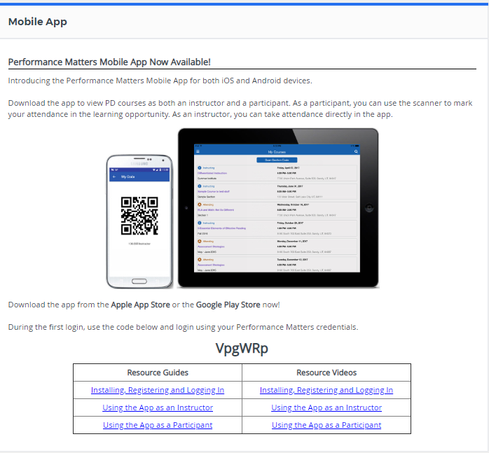
Options for taking attendance on the mobile app:
- App Roster
  - Tap on the class you would like to take attendance for and locate the roster information on the bottom of the course details.
  - Tap the checkbox next to each participant to mark them as attended. If you incorrectly marked someone as attended, tap the checkmark to change their status back to absent.
- Participant QR Codes
  - Prior to the start of the course, print each participant a name tag or table tent with a QR code on it through the Section Roster screen under Courses I am Teaching on the desktop login.
  - Click on Name Tags and Table Tents.
  - If choosing to print table tents, check the box for Include QR Code checkbox and then click Print Table Tents. Follow instructions to print. If choosing to print name tags, choose the type of labels you would like to print, click on the name of the label, and then following the instructions to print.
  - Click Close Window when done.
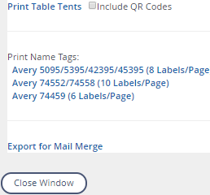
  - In the mobile app, tap on the class you would like to take attendance for and locate the roster information on the bottom of the course details.
  - Tap Scan Attendee Codes.
  - Scan the QR code from the name tag or table tent for each participant to mark them as attended. A participant can also display their QR code on their mobile device if they have downloaded the app and you can scan the code on their mobile app screen to mark them as attended.
  - A window will pop up after each person’s QR code you scan to confirm attendance has been recorded for that participant.
- Section QR Code
  - Prior to the start of the course, print a sign in sheet with the QR code through the Section Roster screen under Courses I am Teaching on the desktop login.
  - Click Sign In Sheet on the Section Roster screen.
  - Click Print Section Code on the sign in sheet that is created and follow directions to print.
  - When you are done, close the browser and return to the Section Roster screen.
  - Post the Section Code in the room your course will be located in and tell participants they are able to scan in and marked themselves as attended on their mobile devices if they have the Performance Matters app. Please note: participants are not required to download the mobile app so you will still need to take attendance using another method for those that do not have the app on their device.

SUBMIT ATTENDANCE FOR CREDIT APPROVAL
- Once the section is completed and you have taken attendance for all participants, click Submit for Credit Approval on the Section Roster screen on the Courses I am Teaching Tab.
- Click OK.
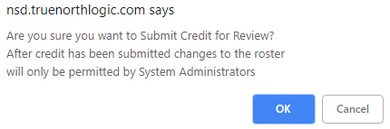
- Human Resources will then award credit based on the attendance information entered. Clock hours will be visible to participants after Human Resources has awarded them and the participant has completed the course survey
- If a participant attends less than the full time frame of the section, mark them as attended and email staffdev@nsd.org with the section number, employee name, date, and number of hours the participant attended. Human Resources will adjust the credit awarded accordingly.

MANAGE THE WAITLIST
- Click Waitlist on the Section Roster screen.
- To make changes to users on the waitlist either click Register next to the user to move them to the roster or click X to remove them from the waitlist. Click OK to confirm.
- Click Manage Roster to finalize the changes and return to the roster.

REMOVE PARTICIPANTS
- Click Remove Participants on the Section Roster screen.
- Click the checkbox next to the participants you would like to remove from the roster or waitlist.
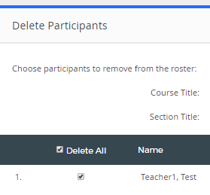
- To send a notification to the participant being remove from the roster, click the checkbox next to Send notification emails.
- Click Delete to remove selected participants.

EMAIL/MESSAGE PARTICIPANTS
- Click Email All on the Section Roster Screen.
- Create your email to participants.
- Check the box next to (All) to send the email to all participants or check the box next to the participants you would like to send to.
- Click Send to send the email to selected participants.
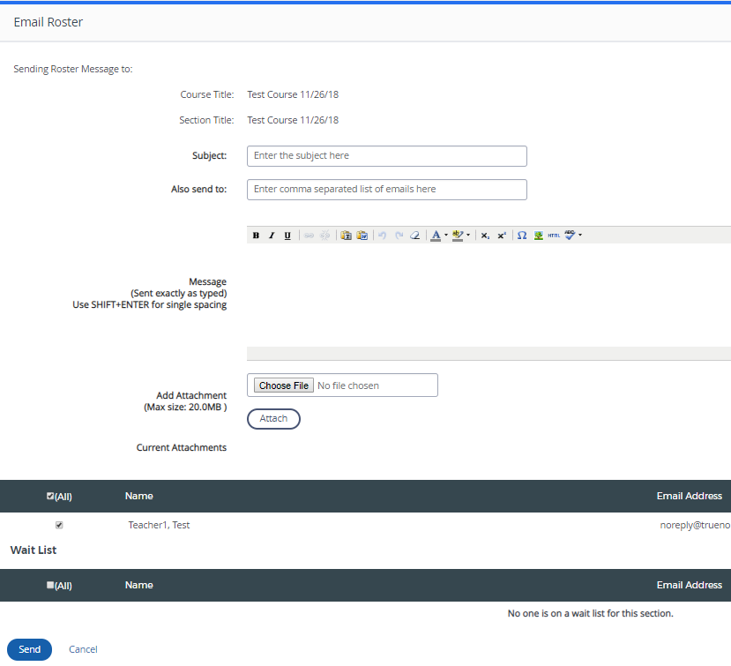
Messages can be sent in the system by clicking Messages on the Section Roster Screen. This will allow you to send messages through the system and will be available to recipients by clicking on the envelope on the top of the menu. Note: This does not send an email to their NSD email address so users will not see it unless they are signed into the PD system. We recommend for important information to send an email or a message and an email.

ADDITIONAL HELP INFORMATION
For more documentation and videos on navigating the system, visit the Performance Matters Online Help Center by clicking the question mark icon on the top right of the screen.
For additional questions not answered by this guide or the resources in the professional development system, contact Human Resources at staffdev@nsd.org

